In the game of Power Countdown, you use a set of numbers to make a target number, but unlike the usual Countdown game where you can use +,−,× or ÷, the only operations you can use are raising a number to a power, taking the reciprocal of a number, or finding the product of two numbers.

Each number can only be used once. You don't have to use all the numbers. There is often more than one way of making a particular target, so see how many different ways you can find.

Here is an example:
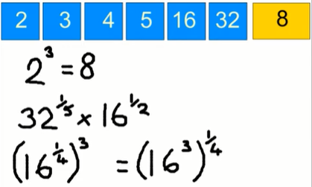
Can you find any other ways of making 8?
Are there any ways which use all the numbers?

Here is another selection.

How many ways are there to make the target number of 125?

Below is a selection of numbers and five targets.



How many different ways can you find to make each target?

Are there any targets you can't make? How close can you get?

